**TESLA COIL TRANSMITER**

1. Transformator Step up

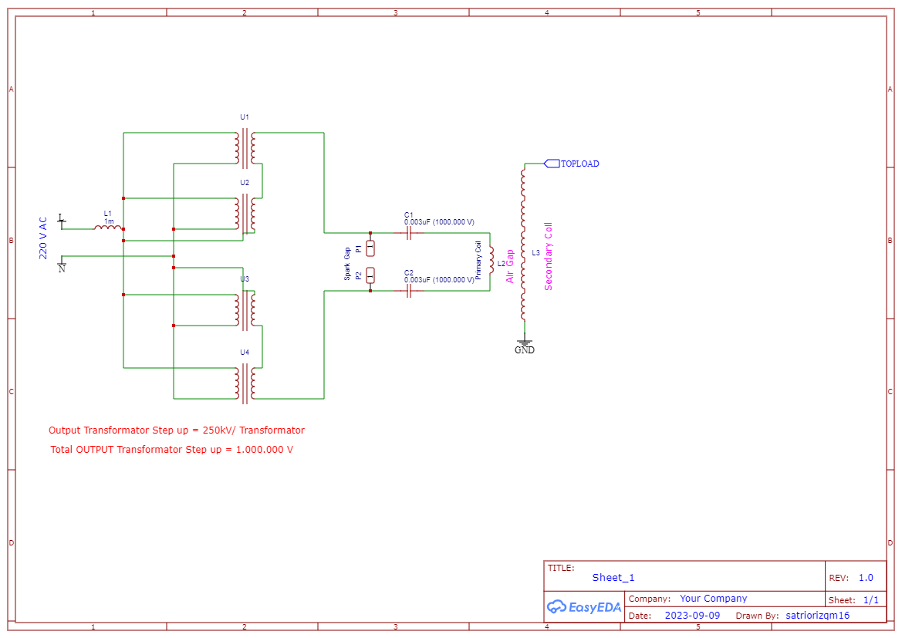

* **Step up transformer calculation formula**

$\frac{Vp}{Vs}$ = $\frac{Np}{Ns}$

Vp (Input) = 220 VAC

Vs (Output) = 10 kV

Result :

$$\frac{220}{10kV}= \frac{11}{500}$$

Np : Ns = 11 turn : 500 turn

= 10 kV/transformator

To make 40.000 volt for tesla coil we can installed 4 transformator step up like in the schematic picture on the top.

(u1, u2, u3,u4) is a Transformator Step Up

1. Multi Mini Capacitor

* **Individual Capacitor Properties :**

Capacitance : 0,0066 uF

Voltage capacitance : 10 kV

* **MMC Parameters:**

Capacitor per String : 4  
String in Paralel : 5

* **Result of tThe Installed Capacitor:**

Total capacitance : 0,0082 uF

Voltage capacitance : 40.000 V

Number of caps : 20 capacitor/pack

1. Flat Spiral Coil Formula (Primary Coil)

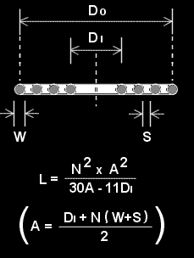Inner Diameter (DI) = 120 mm

Number of Turns (N) = 4

Wire Diameter (W) = 2 mm

Turn Spacing (S) = 1 mm

$$L= \frac{4^{2}× {252}^{2}}{30\left(252\right)-11(120)}$$

$$L=598,677 uH$$

1. Formula Resonant Frekuensi

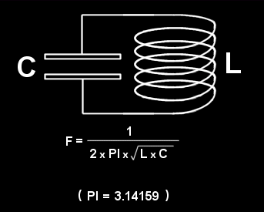

Inductance (L) = 0,598,677 mH

Capacitance (C) = 0.082 uF

$$F= \frac{1}{2 x 3,14159 x \sqrt{0,598,677 } x \sqrt{0.0082}}$$

$$F=71,8 kHz$$

1. Formula Helical Coil

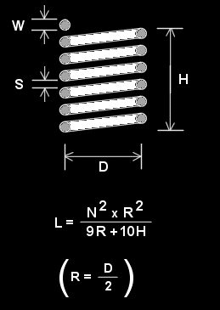

Diameter (D) = 110 mm

Number of turns (N) = 1200

Wire diameter (W) = 1 mm

Turn spacing (S) = 0.5 mm

Radius (R) = 55 mm

Height (H) = 1,8 m = 1800 mm

Length of wire = 414,689 m

$$L= \frac{{1200}^{2} x {55}^{2} }{9\left(55\right) x 10(1800)}$$

$L= 9272.563 uH$

1. Estimated Spark Size

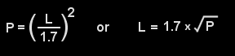

Input Power (P) : 40.000 V x 1000 mA = 40.000 Watt

$$Spark Length \left(L\right)=1.7 x \sqrt{10.000}$$

$Spark Length \left(L\right)=340 inches$

1. Output Voltage from Tesla Coil Formula

To calculate the winding ratio (Coil Ratio) between the primary and secondary windings on a tesla coil with an input voltage (Vp) of 400 kVAC and an output voltage (Vs) of 1,000,000 VAC, we can use the basic transformer formula:

$$\frac{N1}{N2} = \frac{V1}{V2}= \frac{400kV}{1.000kV}= \frac{2}{5}$$

So, the voltage winding ratio between the primary and secondary windings on this tesla coil is 1:25. This means that each 1 winding on the primary side corresponds to 25 windings on the secondary side to achieve a voltage output of 1,000,000 VAC when the input is 40 kVAC.

1. Sparks gap

Diameter Copper : 40 mm

Length : 10 cm

Vin : 40kV

I : 100 mA

$$Resistance Copper= \frac{40.000}{0,1}=400.000 ohm$$

In this situation, you can buy some copper wire and connect it in a series to create a circuit with a total resistance of 400,000 ohms. This will allow you to generate a current of 100mA.

To do this, you need to calculate the length of copper wire needed for each segment to reach the desired resistance. Then, connect these wire segments in a series, which means connecting the positive end of one segment to the negative end of the next one until you reach the total resistance of 400,000 ohms.

By following these steps, you can create a circuit that produces the desired current using copper wire.

1. 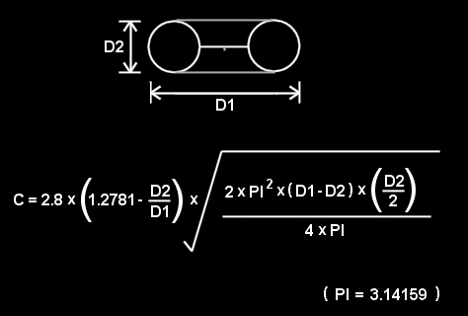Top Load

D1 = 120 mm

D2 = 100 mm

$$C=2,8 x \left(1,2781- \frac{100}{120}\right)x \sqrt{\frac{2 x {3,14159}^{2} x \left(120-100\right) x (\frac{100}{2})}{4 x 3,14159}}$$

$$C=1,943 pF$$

$$F= \frac{1}{2 x 3,14159 x \sqrt{9,27 } x \sqrt{0.000007601}}$$

$$F= 599,494 kHz$$

* Final Output From Tesla Coil

V = 1.000 kV

F = 599,494 kHz

Tesla coil is often used in experiments where the load resistance (R) can be very high or even non-existent. In these cases, the current generated by the tesla coil can be so low as to be almost undetectable.

So, to calculate the current generated by the tesla coil, you need to know the value of the load resistance (R) connected to the tesla coil at that time. If the resistance of the load is unknown, then it is impossible to accurately calculate the current. Tesla coil is usually used to generate high voltage, and its current depends on the resistance of the load and the design of the tesla coil itself.

**TESLA COIL RECEIVER**

This is a diagram block of a Tesla Coil Receiver. Its primary function is to step down the voltage from 1000 kV to 230 V. Additionally, it includes a frequency converter component to make it compatible with common electronic devices. Furthermore, there is an optional 48 V charger adaptor for recharging batteries.

* Surge Arrester

This cord is employed to initiate a spark within a Tesla coil and then direct the resulting discharge to the ground using energy harvesting and storage devices. The surge arrester is manufactured from a Cadmium copper alloy, comprising roughly 98% copper, 1% cadmium, and 1% other elements. You can adjust the height of the surge arrester to match the height of the Tesla coil, within a range of 340 inches.

* Surge energy harvester

In a high-voltage surge energy harvesting system, various components like safety gaps, transformers, surge gaps, converters, and supercapacitors are used in a specific arrangement to convert high-voltage surges into storable energy while ensuring safety. To keep 1,000,000 volts (1 MV) safe:

1. Isolate and insulate components.
2. Use surge protection and proper grounding.
3. Monitor and control the system.
4. Follow safety standards and regulations.
5. Ensure trained personnel handle the system.

Safety is crucial when working with high voltages, and expert advice is recommended.

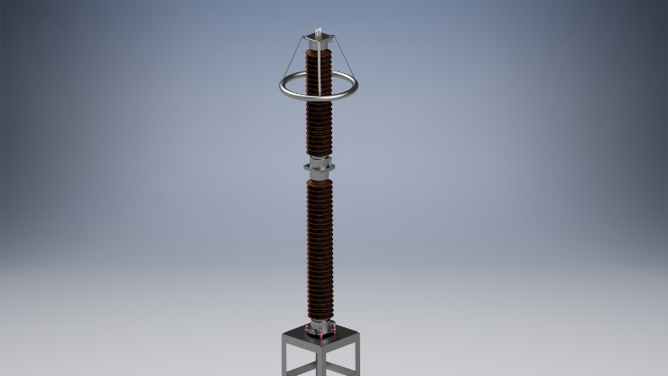

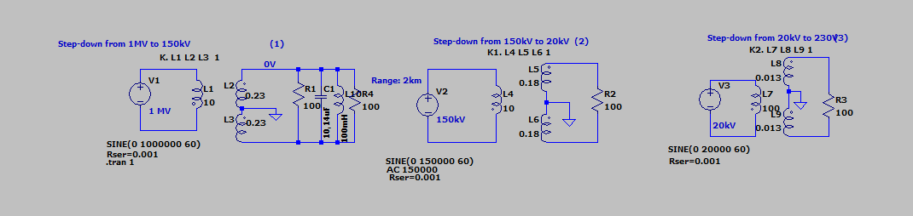The example of Surge Arrester and Surge Energy Harvester

* Transformator (1)

Trafo step-down from 1M V to 150kv :

Voltage must be step-down until 150kV to make small current for the cable, that’s make the cheap cost for cable.

$$\frac{N1}{N2} = \frac{1MV}{150KV}= \frac{100}{15}$$

Np : Ns = 100 turn : 15 turn

Result output :

For decrese the High Frequency Tesla Coil, put the capacitor and Inductance.

$$50= \frac{1}{2 x 3,14159 x \sqrt{1 } x \sqrt{C}}$$

$$98.596 = \frac{1}{ \sqrt{L } x \sqrt{C}}$$

$$98.596 = \frac{1}{ \sqrt{1 H } x \sqrt{C}}$$

$$C = \frac{1}{98.596}=0,00001014 F=10,14 uF$$

So with the formula of capacitor and inductance the frequency will be decreasing to 50Hz. The frequency 50Hz is save for electronics component.

* Transformator (2)

Trafo step-down from 150kV to 20kv :

$$\frac{N1}{N2} = \frac{150kV}{20KV}= \frac{150}{20}$$

Np : Ns = 150 turn : 20 turn

Result output :

* Transformator (3)

Trafo step-down from 20kV to 230 V :

$$\frac{N1}{N2} = \frac{20kV}{230V}= \frac{2000}{23}$$

Np : Ns = 2000 turn : 23 turn

Result output :

In this case, you can charge the battery using a charger adapter specifically designed for batteries. This allows you to adjust the charging voltage as needed. For example, if you want to charge the battery to 48 volts, you can simply use a 48-volt charger adapter.